Remember & Understand

Q1. Distinguish between forward error corrections versus error correction by retransmission.

In forward error correction, the receiver tries to correct the corrupted codeword; in error detection by retransmission, the corrupted message is discarded (the sender needs to retransmit the message).

Q2.What is the Hamming distance? What is the minimum Hamming distance?

The Hamming distance between two words (of the same size) is the number of differences between the corresponding bits. The Hamming distance can easily be found if we apply the XOR operation on the two words and count the number of 1s in the result. The minimum Hamming distance is the smallest Hamming distance between all possible pairs in a set of words.
To guarantee detection of upto ‘s’ error the minimum hamming distance must be s+1.
To guarantee detection of upto ‘t’ error the minimum hamming distance must be 2t+1.

Q3: How does Single bit differ from Burst error

In a single bit error only one bit of a data unit is corrupted; in a burst error more than one bit is corrupted (not necessarily contiguous).

Q4: Apply the following operations on the corresponding polynomials:
- (x³+x²+x+ 1) + (x⁴+x²+x+ 1)
- (x³+x²+x+ 1) − (x⁴+x²+x+ 1)
- (x³ +x²) × (x4 +x² +x +1)
- (x³+x²+x+ 1)/(x²+ 1)

a. (x³+x²+x+ 1) + (x⁴+x²+x+ 1) = x⁴ + x³
b. (x³+x²+x+ 1) − (x⁴+x²+x+ 1) = x⁴ + x³
c(x³ +x²) × (x4 +x² +x +1) = x⁷ + x⁶ + x⁵ + x²
d. (x³+x²+x+ 1)/(x²+ 1) = x + 1 (remainder is 0)

Analyze & Learn

Q1.What kind of error is undetectable by the checksum?

At least three types of error cannot be detected by the current checksum calculation. First, if two data items are swapped during transmission, the sum and the checksum values will not change. Second, if the value of one data item is increased (intentionally or maliciously) and the value of another one is decreased (intentionally or maliciously) the same amount, the sum and the checksum cannot detect these changes. Third, if one or more data items is changed in such a way that the change is a multiple of 216 − 1, the sum or the checksum cannot detect the changes.

Q2: Can the value of checksum be all 0’s? Justify? Can it be all 1’s? Justify?

The value of a checksum can be all 0s (in binary). This happens when the value of the sum (after wrapping) becomes all 1s (in binary). It is almost impossible for the value of a checksum to be all 1s. For this to happen, the value of the sum (after wrapping) must be all 0s which means all data units must be 0s.

Q3: In CRC show the relationship between the entities?
a. The size of the data-word and the size of the code word.
b. The size of the divisor and the reminder.
c. The degree of the polynomial generator and the size of the divisor.
d. The degree of the polynomial generator and the size of the reminder.

a. The only relationship between the size of the codeword and dataword is the one based on the definition: n = k + r., where n is the size of the codeword, k is the size of the dataword, and r is the size of the remainder.
b. The remainder is always one bit smaller than the divisor.
c. The degree of the generator polynomial is one less than the size of the divisor.
d. The degree of the generator polynomial is the same as the size of the remainder (length of checkbits).

Q4: How is single parity check differs from two dimensional parity check.

The single parity check uses one redundant bit for the whole data unit. In a two dimensional parity check, original data bits are organized in a table of rows and columns. The parity bit is then calculated for each column and each row.

Q5: We need a dataword of at least 11 bits. Find the values of k and n in the hamming code C (n, k) with d_{min} =3
We need to find k = 2m −1 − m ≥ 11. We use trial and error to find the right
answer:
a. Let m = 1 k = 2m −1 − m = 21 −1 − 1 = 0 (not acceptable)
b. Let m = 2 k = 2m −1 − m = 22 −1 − 2 = 1 (not acceptable)
c. Let m = 3 k = 2m −1 − m = 23 −1 − 3 = 4 (not acceptable)
d. Let m = 4 k = 2m −1 − m = 24 −1 − 4 = 11 (acceptable)
The code is C(15, 11) with dmin = 3.

Q6: Which of the following CRC generators guarantee the detection of a single bit error?
a. x³ + x+ 1
b. x⁴ + x²
c. 1
d. x² + 1.

To detect single bit errors, a CRC generator must have at least two terms and the
coefficient of x0 must be nonzero.
a. x³ + x + 1 → It meets both critic.
b. x⁴ + x² → It meets the first criteria, but not the second.
c. 1 → It meets the second criteria, but not the first.
d. x² + 1 → It meets both criteria.

Understand & Evaluate

Q1.What is the Hamming distance for each of the following code words:
a. d (10000, 00000)
b. d (10101, 10000)
c. d (11111,11111)
d. d (000, 000)

a. d (10000, 00000) = 1
b. d (10101, 10000) = 2
c. d (1111, 1111) = 0
d. d (000, 000) = 0

Q2.Assuming even parity, find the parity bit for each of the following data units.
a. 1001011
b. 0001100
c. 1000000
d. 1110111

Dataword Number of 1s Parity Codeword
a. 1001011 → 4 (even) → 0 10010110
b. 0001100 → 2 (even) → 0 00011000
c. 1000000 → 1 (odd) → 1 10000001
d. 1110111 → 6 (even) → 0 11101110

Q3. What is the maximum effect of 2-ms burst of noise on data transmitted at the following rates?
a) 1500 bps
No. of affected bits per sec = Data rate x Burst duration = 1500 x 2 x 10 -3 = 3 bits

b) 100 Kbps
No. of affected bits per sec = Data rate x Burst duration = 100 x 10 3 x 2 x 10 -3 = 200 bits

Q4. Apply the XOR operation on the following pair of pattern : 100001 ⊕ 100010

100001 ⊕ 100010 = 000011

Q5. Assuming even parity, find the parity bit for each of the following data units.
a) 1011011 b) 0001100

a) 1011011
No. of 1’s in the data = 5 In even parity, no. of 1’s in final transmitted data even. Append 1 at the end. Final transmitted data = 10110111

b) 0001100

No. of 1’s in the data = 2 In even parity, no. of 1’s in final transmitted data even.

Q6 Given the data word 10100111 and the divisor 10111.Show the generation of the codeword at the sender site (using binary division). Show the checking of the codeword at the receiver site (assume no error).
Ans. CRC is 0001 Codeword is 101001110001

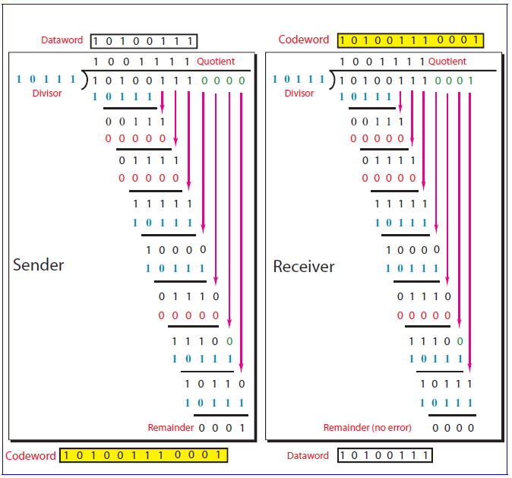

Q7. Suppose the seven bit data word 1101110 is to be encoded using an even-parity Hamming code. What is the binary value after encoding? Now assume that the 6th bit got corrupted during transmission. Find the error correcting codes.

Ans. Redundancy bits required =4, since m=7

d₁₁ | d₁₀ | d₉ | r₈ | d₇ | d₆ | d₅ | r₄ | d₃ | r₂ | r₁
1 | 1 | 0 | r8 | 1 | 1 | 1 | r₄ | 0 | r₂ | r₁

r₁=3,5,7,9,11 =0,1,1,0,1=1
r₂ = 3,6,7,10,11=0, 1,1,1,1=0
r₄=5,6,7=1,1,1=1
r₈=9,10,11=0,1,1=0

The binary value after encoding=11001111001

Now d6 got corrupted that is it becomes 0

Receiver got =1 1 0 0 1 0 1 1 0 0 1

C₁= 1, 3, 5, 7, 9, 11=1, 0, 1, 1, 0, 1=0
C₂=2, 3, 6, 7, 10, 11=0, 0, 0, 1, 1, 1=1
C₄=4, 5, 6, 7=1, 1, 0, 1=1
C₈=8, 9, 10, 11=0, 0, 1, 1=0

Therefore the position is = (0110)₂ = 6, receiver will invert 6th bit.

Q8.Find CRC if data word is 10100111 and generator polynomial is 10111.What is codeword sent by sender? Show the checking process at receiver side by assuming no error.
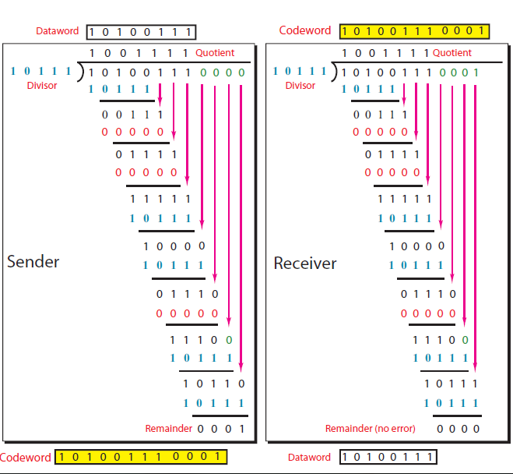

Q9: Find CRC if data word is 1010011110 and generator polynomial is 10111 after converting it into polynomial using polynomial division. What is codeword sent by sender? Show the checking process at receiver side by assuming no error.

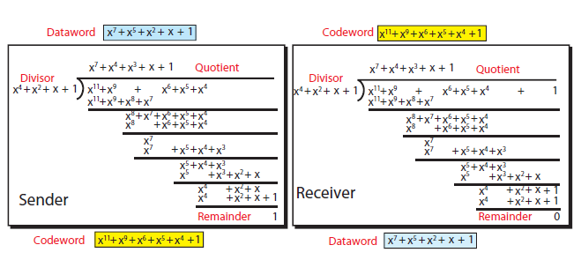

Q10: A sender needs to send the four data items 0x3456, 0xABCC, 0x02BC, and 0xEEEE. Answer the following:
A. Find the checksum at the sender site.
B. Find the checksum at the receiver site if there is no error.
C. Find the checksum at the receiver site if the second data item is changed to 0xABCE.
D. Find the checksum at the receiver site if the second data item is changed to 0xABCE and the third data Item is changed to 0x02BA.

- In part a, we calculate the checksum to be sent (0x2E32)
- In part b, there is no error in transition. The receiver recalculates the checksum to be all 0x0000. The receiver correctly assumes that there is no error.
- In part c, there is one single error in transition. The receiver calculates the checksum to be 0FFFD. The receiver correctly assumes that there is some error and discards the packet.
- In part d, there are two errors that cancel the effect of each other. The receiver calculates the checksum to be 0x0000. The receiver erroneously assumes that there is no error and accepts the packet. This is an example that shows that the checksum may slip in finding some types of errors.

